RDHL-200X Loop Resistance Tester

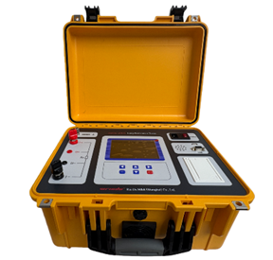
RDHL-200X Loop Resistance Tester is a high-precision, digital switch detection instrument carefully developed by our company to leverage our technological advantages. This instrument can adopt a constant current output of 200A, with an output voltage of up to 10V, and can measure micro ohm level contact resistance. It is widely used to measure the contact resistance, loop resistance of various switches and electrical appliances, and the contact resistance of cables, wires and welds. The instrument has accurate measurement data and stable performance, meeting the requirements of on-site high-voltage switch maintenance of electric power and power supply departments and loop resistance test of high-voltage switch factory.

- Product features

- Equipped with automatic testing function, it can automatically start and stop testing; Automatically save and print test data; Continuous testing can be conducted without the need to operate instruments.
- The 5.6-inch ultra large industrial grade high brightness color LCD screen displays clearly and visibly even in strong sunlight.
- Equipped with a built-in GPS module, it has GPS automatic timing and positioning functions to ensure accurate clock operation.
- Equipped with RS232 communication interface, it can realize remote control and data upload of the instrument.
- Multiple current levels are available, including 200A, 150A, 100A, 50A, and 25A, making testing more flexible.
- It has multiple protection functions such as overvoltage protection, open circuit protection, and overheating protection.
- Built in large capacity storage, capable of storing 800 test records.
- It has a USB interface and can be connected to an external USB drive to import test data into the USB drive, making it convenient to write test reports.
- Product specifications and technical parameters
- Test current: 25A, 50A, 100A, 150A, 200A
- Range: 50 ~ 300mΩ (25A) 30 ~ 140mΩ (50A) 0 ~ 50mΩ (100A)
0 ~ 20mΩ (150A) 0 ~ 10mΩ (200A)
- Resolution: minimum 0.1µΩ
- Accuracy: ± (0.5%rdg + 1µΩ)
- Testing time: Fast, 10s, 20s, 30s, 40s, 50s, 60s
- Power: ≤2000W
- Working mode: constant current limited voltage, output voltage can reach 10V
- Working power supply: AC220V±10% ; 50Hz/60Hz
- Service temperature: -10 ~ 50℃
- Relative humidity: ≤ 90%, no condensation

